
Affordability | Churned Occasional Cx Research Report
Aug 23, 2022 | Kelly Peterson Vero Jimenez Research Brief

| Business context: There are ~100M Cx US-wide that place <2 orders a month on DoorDash. These “Occasional Cx” represent a significant opportunity for growth for DD. If we are able to increase these users OF, we can not only grow DD GMV, we can make the DashPass value prop more compelling for these Cx and convert them into long term retained / DP users.

| Research Objective & Approach: Identify the top hooks, benefits and values that must be met for occasional Cx that have churned to return to DoorDash
This research utilized a two phase approach:
- Phase I: Survey (N=1405 Occasional Cx responded, n=668 Churned Occasional Cx completed)
- Phase II: 1:1 Moderated interviews (n=5 Churned Occasional Cx)

| TLDR

Churned Occasional Cx left DoorDash primarily for cost related reasons with some secondary reasons around quality, guilt and supporting local
  - While delivery fees are the greatest pain point felt (followed by price inflation) Cx are more likely to be focused on the overall subtotal when deciding to walk away

- Consistent opportunities to save money are the greatest lever to get Cx back. Guarantees around total fees and in-store prices will help entice Churned Occasional Cx
  - High value offers like BOGO and $$ off your next order are likely to bring Cx back, but are less likely to lead to sustained ordering; knowing that these will be available at a regular cadence can help
  - Churned occasional Cx that order takeout at least weekly are interested in free delivery for a extended period of time (DashPass)

- Most Churned “Occasional Cx” are occasional due to their natural takeout frequency, not for a DoorDash specific reason. Goals should be focused on resurrection rather than increasing the number of monthly purchases

| Recommendations:
- Experiment with “flat fees”(excluding tip). Cx think about “overall cost” rather than individual fees when placing an order. Making it more predictable may help to improve perceived affordability. Consider testing with $5, $3 and $1.99.

- Provide fee caps promises. Cx want to know that they will not receive an unreasonable amount of price inflation + fees. Ensure Cx that there will be limitations (e.g. fees no more than 10% of your total order)

- Build more entry points for affordability discovery throughout the Cx journey beyond the homepage (e.g. within cuisine and Rx pages)

- Experiment with longer DashPass trials or DashPass grace periods (adding a free month when Cx are at risk of churn).
  - Continue to explore partnership opportunities that will bring more Cx DashPass access without additional cost

| Additional Questions & Discussion Points:
- How do Churned Occasional Cx opinions differ if they have a subscription service to competitor vs. not?
- How do previous DashPass Churned Cx differ?
- What behavioral markers do we have to “predict” churn?

| Appendix I: Detailed Quant & Qual Insights:
While we can resurrect Occasional Cx, the majority are unlikely to increase order frequency
Two-thirds of Churned Occasional Cx order restaurant/food delivery regularly, indicating that the majority of Cx natural behaviors align with ordering <2 times a month. DoorDash should not prioritize increasing the number of orders Churned Occasional Cx make per month as the majority of them are unlikely to do so.

For one-third of these Cx there is an opportunity to turn them to more regular users if resurrected as they are likely to order restaurant or food delivery at least once a week.
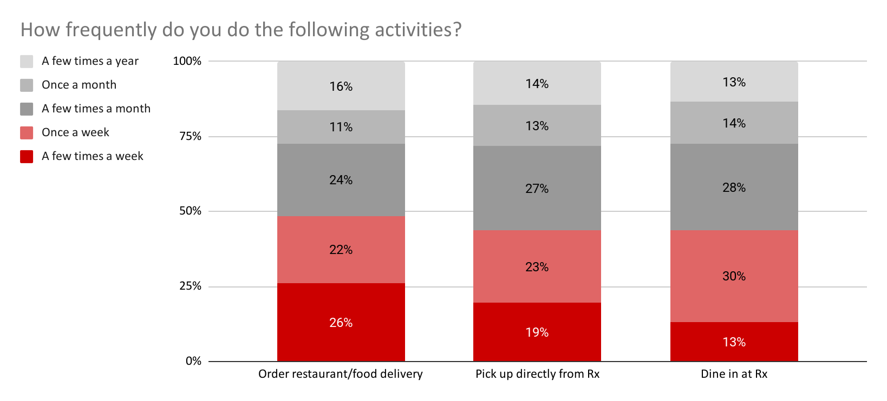

Few will return on their own, the majority need to see major differences in affordability to return.
Approximately one-third of Churned Occasional Cx stated that they are very or somewhat likely to return to DoorDash in the next month. If we apply the Bayesian Truth Serum, a technique developed to provide a more accurate assessment of how survey answers will play out in real life, the expected percentage of Cx who will naturally return is approx 12%. Those that stated they are likely to use DoorDash in the next month have cited reasons like moving/traveling, expected changes in financial situation, expected inconvenience times or access to free DashPass/credits to use.

The remaining respondents are on the fence or fairly certain they will not return, and will be more difficult to convert. When asked why they selected they are unlikely to use DoorDash top answers included reasons related to cost, delivery quality and changes in lifestyle (e.g. cooking at home more, not eating out as much).

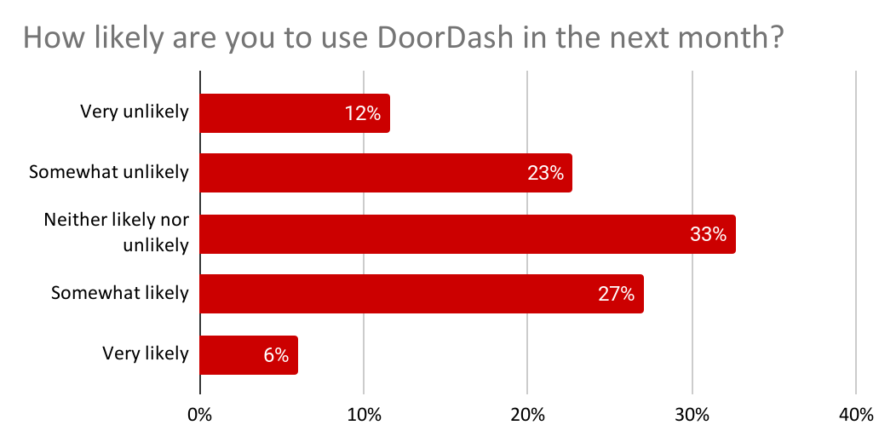
Base: Total Churned Occasional Cx (n=233)

Cost concerns drive churn, secondary factors around quality, guilt and supporting local.
As seen in previous UX research (see Appendix II below) functional price related barriers ( delivery fees, inflation and service fees) are the top drivers of churn. This is followed by more emotional barriers of loyalty to a different app/subscription or guilt and frustration with quality that ultimately leads to churn.
Churned Occasional Cx who order takeout weekly or more often rank much higher on preference for another delivery service/app. (See below for more details on DashPass & loyalty programs.)
In qualitative conversations we understand that consumers can feel sticker shock. Cx suspect menu inflation and fees to be driving the difference between their expected vs. actual subtotal. They compare the cost of ordering on DoorDash to the cost of alternatives:
  - Ordering food through other delivery services that offer coupons
  - Ordering food through other subscription services (E.g., GrubHub+, UberEats/UberOne)
  - Picking up at Rx
  - Dining in at Rx
  - Cooking at home

Additionally, affordability and selection go hand in hand. Cx prefer deals and coupons that help them get more bang for their buck at the Rx/stores they are already ordering from or have an interest in ordering from.

Overall Weighted Ranking | Item | % of Churned Occasional Cx Selected As Reason for Churn | Average Ranking (Out of 5)
1 | The delivery fees are too high | 53% | 2.3
2 | The prices of items are too high | 39% | 2.7
3 | The service fees are too high | 59% | 2.0
4 | I prefer/switched to using other delivery apps such as UberEats, GrubHub etc. | 30% | 2.5
5 | I feel guilty spending money on delivery | 25% | 2.5
6 | I was facing frequent issues with my deliveries | 20% | 2.1
7 | I started ordering from restaurants directly | 22% | 2.8
8 | I started cooking at home regularly | 21% | 2.8
9 | The restaurant/items I want to order are not on DoorDash | 19% | 2.7
10 | I started dining out more regularly | 9% | 2.4
11 | I am trying to eat healthier | 12% | 3.3
12 | DoorDash customer support did not meet my expectations | 9% | 2.3
13 | I don’t like having to tip | 12% | 3.4
14 | My DashPass got canceled | 4% | 2.7
15 | I found the DoorDash app hard/confusing to use | 3% | 2.8
Base: Total Churned Occasional Cx (n=233)

Financial levers that “stop the sticker shock” are of greatest interest to Churned Occasional Cx.
The greatest opportunities are likely to exist from fixed flat fees, evergreen recurring $ off promotions, BOGO or caps on inflation.
Churned Occasional Cx who are in larger households (3+ people in household) have a stronger preference for “guaranteed in-store prices” and “BOGO meal promotions” than their smaller household counterparts. These larger households feel the need to “get more for their money” as they perceive the need to stretch a dollar further than smaller households.
Occasional Churned Cx who order out more frequently (1 or more times a week) are more interested in “no delivery fees for a set amount of time” than their counterparts. This counterpart is also more likely to have left DoorDash for another subscription service, so targeting them with DashPass trials or extended trials may help to make DoorDash stickier for them in the future.
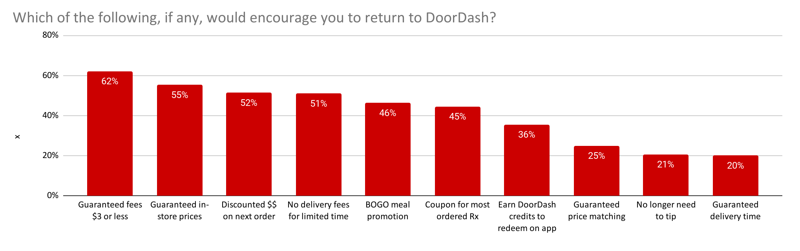Base: Total Churned Occasional Cx (n=233)
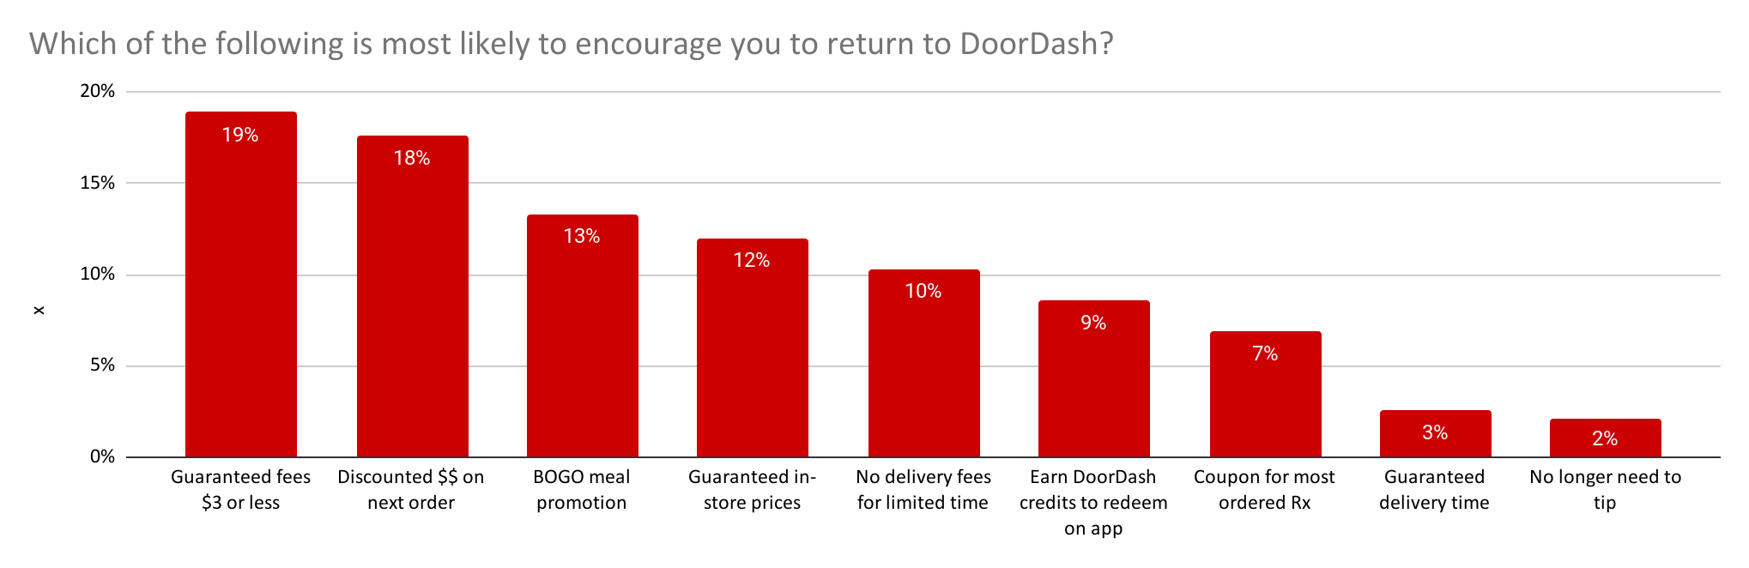Base: Total Churned Occasional Cx (n=233)

DashPass may be an important lever to avoid churn AND resurrect.
One-third of Occasional Cx that have churned have had DashPass in the past, there is likely an opportunity to stop this churn through extended DashPass grace period offers or trials. Churned occasional Cx are looking for ways to ensure affordability and DashPass is a strong lever to do so.
DashPass subscribers want to get the most value out of their benefits. They expect DoorDash to help them discover the best deals at the best restaurants that are only available to them.

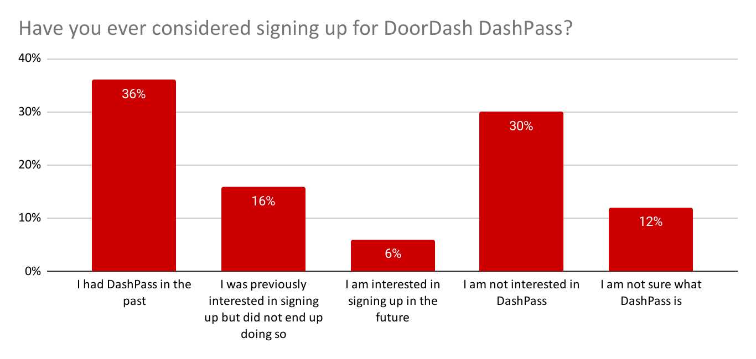
Base: Total Churned Occasional Cx (n=233)
Question: Q5. How likely are you to order from DoorDash in the next month?
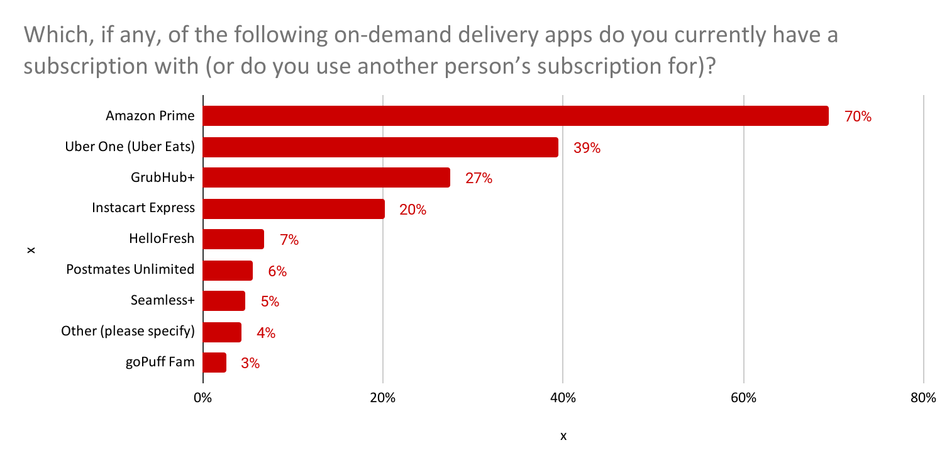
Base: Total Churned Occasional Cx (n=233)
Question: Q5. How likely are you to order from DoorDash in the next month?

Cx are quick to sign up for free, point-based reward programs but not committed to them. They hope that today’s spending can lead to future savings (e.g., free meal) but are skeptical about their value. Note, some Cx complained about UberOne’s point-based reward program because they haven’t been able to redeem points for a real reward (e.g., a free ride) due to rules & conditions. A points system is of interest for DoorDash but needs to be seamless and automated to truly impact purchasing behaviors.

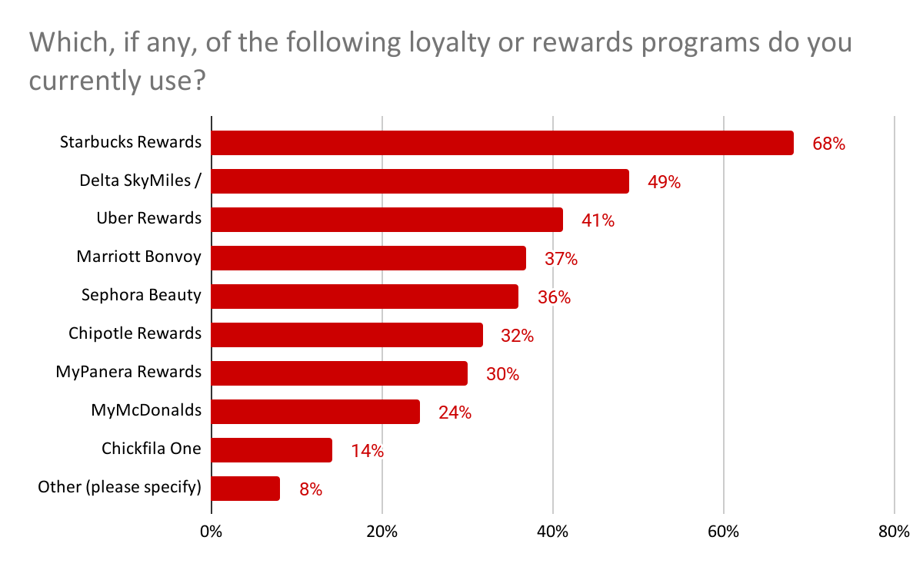
Base: Total Churned Occasional Cx (n=233)

| Appendix II: What we know so far:

Why do Cx churn? Report: Churned Users
- Price: users report high fees, inflated pricing on DD as well as lack of relevant promos or loyalty rewards to keep them engaged.
- Consumers are comparatively shopping between apps for specific meals from restaurants, and looking at fees which make a lasting perception of higher fees for all restaurants on DoorDash. Many consumers mentioned specific meals where they noticed being lower on competitive sites like UberEats which set their perception of DoorDash overall.
  - UberEats is the biggest competitive barrier for why consumers churned with ~10% of very churned consumers mentioning them as part of their reason for leaving. While most of the reasons revolved around the perception of UberEats having lower fees, ~5% specifically called out UberEats loyalty program being motivating.
- High defect rates (esp. M&I) with Customer support not being able to recover: due to unintuitive self-help, superficial resolutions and long refund times
- Delivery time: many users reported seeing long and/or increasing delivery times, which in turn affected their food quality
- Benefits of ordering from Rx directly: this includes tangible (e.g. rewards, loyalty points, no markups, service fee) as well as intangible benefits (e.g. fewer M&Is, fresher food, supporting local Rx). For pick-up specifically, we hear that Rx requests direct orders from Cx

We also know that Cx tend to ramp down on their orders for the following reasons: Report: Ramp Up/Ramp Down
- The cost outweighs the benefits. Desire to save money is the number one reason why users turn away from high-frequency ordering, followed by a focus on cooking and health/diet choices. Yet, when asking about the DoorDash platform specifically, late/incorrect deliveries and negative restaurant/dasher experiences were also identified as contributing factors for ramping down.
- Impacted by negative app experiences including changes to the app they did not like. As former high-frequency users, Ramp Down users are keenly aware of changes to fee structure, how dashes are executed, and how restaurants behave on the DoorDash platform. When describing causes for ramp down, users readily describe negative experiences with food quality, dasher service, length of time for delivery, and canceled orders.

Why have churned Cx resurrected in the past? Report: Very Churned & Recently Resurrected
- New need for convenience: Moving, new jobs and general changes in pace of life (slower or busier) lead to need for more convenience due to lack of time or lack of motivation. Often this return to DoorDash is viewed as a splurge or treating one self.
- Interest or use in DashPass: Cx started receiving DashPass benefits through Chase and therefore starting ordering again, some Cx mentioned receiving DashPass through their work
- Situational change: Falling ill, not having access to a car or facing another situation that makes it hard for them to get around
- Triggered by gift card
- New baby/new family member: many also mentioned receiving a gift card in this scenario
Additionally we know that time crunch is the number one motivation behind why users ramped up their DoorDash ordering behavior in the past. Events that ramp up orders are disparate and often specific to the individual user. It would thus be most accurate to say that DoorDash’s promise of convenience and time-saving position the service as a welcome “helping hand” when busy families need it most. Many feel that ordering from DoorDash becomes routine, and DashPass is an important part of ramping up monthly orders as it increases the perceived value of the service. Report: Ramp Up/Ramp Down

Where are the top cost anxieties among Cx (fees, tipping, prices)? Report: NV Perceived Affordability & Value
- Fees are a necessary evil: most Cx indicate that they have to pay a cost for convenience and understand that Dx and DoorDash need to get paid to continue to exist. However, they find the difference between delivery and service fees confusing and often have a hard time understanding how much goes to the Dx; this can make tipping feel more complicated and feel more expensive at times. Cx do not have an issue with tipping in theory, as they are used to tipping at Rx, but when it is added to complicated fees it becomes bothersome.
- Fees are the main contributor to sticker shock because consumers feel that they are inconsistent and therefore hard to predict and budget for. Consumers are confused about how fees are determined because they change across restaurants/stores. E.g., nearby restaurants can charge a higher fee than more distant restaurants. Even DashPass subscribers struggle to articulate how much they save on fees and the mechanism that enables savings. (Report: Understanding frequent Cx visitor drop off).
- Fees + higher prices feel like too much: Cx start to get incredibly frustrated when they are asked to pay higher prices than in store and fees. While some Cx understand that higher prices may be set by the store itself, a large proportion suspect that it is DoorDash charging them multiple times. Seeing the higher prices, fees and overall total at checkout is often a common reason for cart abandonment (Report: Understanding frequent Cx visitor drop off).
- High inflation in one area=assumed high inflation throughout: Many Cx describe inflation as inconsistent across DoorDash and across other apps. Once they learn or experience a highly inflated item somewhere in the app they are likely to assume high inflation elsewhere.
- Transparency is key: Recent experiments in grocery show that a flat fee or inverse tiered flat fee approach can help to move the needle in terms of order frequency and subtotals due to transparency and clarity around cost. (Results)

What benefits are most important to Cx?
We’ve learned in a recent study about Cx drop off, that customers who do not order during a visit to DoorDash are more likely to come to DoorDash for discovery than those who do. These Cx value seeing coupons that are relevant, transparent, and flexible because they can inspire and help narrow the ordering decision.
- Cx value promos/coupons from DoorDash when they are relevant and provide flexibility. These are the types of promos that Cx mentioned they want to see more of:
  - Pick-up incentive. Ex: 40% off pick-up
  - Minimum spend incentive. Ex: spend $20, save 40%
  - BOGO. Ex: 2 for 1, buy 1 get one ½ off
  - Save on fees. Ex: $1 delivery fee
  - DashPass benefit reminder. Ex: $0 delivery fee

- Gives Cx a workaround: Cx like the idea that they would receive greater discounts if they put in a little work themselves, for example a larger % off their order, but they have to go pick it up themselves
Additionally if we look at some of the badging that Cx indicates is important for them to make a purchase decision we are reminded that when defining value for Cx it is not just about a less expensive item, quality and selection still play a critical role in decision making: Report: Badging
- Wallet Friendly: Cx are looking for something that is perceived as affordable
- Top Rate/Rave Review: Cx still want to get a high quality product meal
- Full Menu: Cx want a wide selection
We also know from evidence research that the following factors are important to Cx when discovering Rx and choosing a food item. Report: Restaurant Evidence Prioritization Study
- When choosing an Rx cuisine type is the most important factor. Followed by offers/deals, average user rating and dietary restrictions
- When selecting an actual food item the price is the most important factor. Followed by written description of the

